05_Discover_Master Template - 1 Dimension (VLookup)
Standard View
Standard View
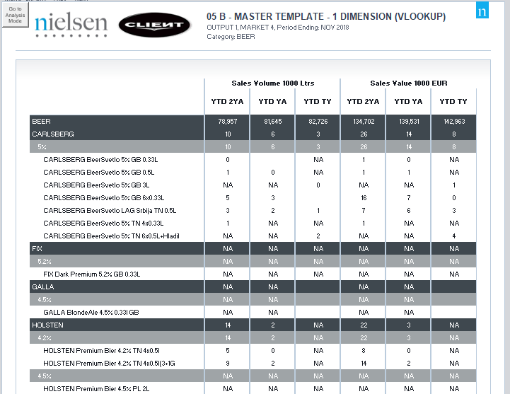

Standard View
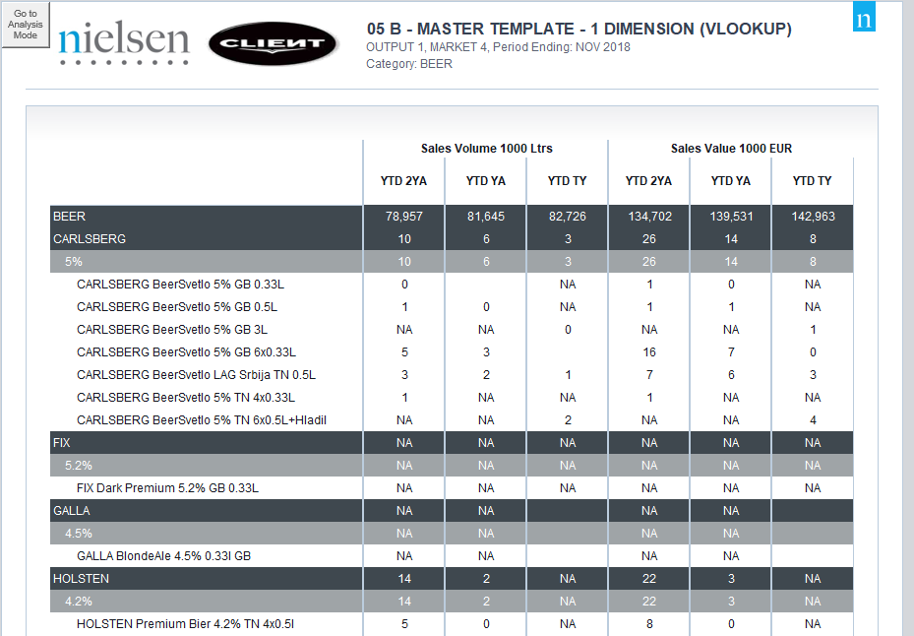
Template Name | 05_Discover_Master Template - 1 Dimension (VLookup)
View Name | - Standard view  - This template is intended for drilled data
Methodology | VLookup
Default Dimension Order | Page Bar | 1 Dimension | Markets
Default Dimension Order | Columns | 2 Dimensions | Periods and Facts
Default Dimension Order | Rows | 1 Dimension | Products
Change dimension | - The dimensions can be swapped except Products dimension  - If a different layout is needed (for example, 2 dimensions on the page bar) please select a different template
Data Selection Guidelines | Facts | Max = 20 facts
Data Selection Guidelines | Products | No limitation
Data Selection Guidelines | Markets | Max = 50 markets
Data Selection Guidelines | Periods | Max = 55 periods
Data Selection Guidelines | NOTE: For the dimension in the Page Bar, the maximum number of items is 100
To create a new report from this template | - Data Selection – needs to be done in the add-in  - Dimension Order – if there is the need to swap dimensions, it needs to be done in the add-in  - Run LoadInputData macro to show Configuration Area and insert source data  - Welcome Sheet – Insert all the needed information on the Configuration Area  - Output Sheet – Insert all the needed information on the Configuration Area  - Add or delete the needed columns to accommodate the retrieved information (always starting from the last populated column to make sure the formulas are carried)  - Depending on the number of periods and facts, the table formatting will have to be adjusted  - To make formatting easier, the existing formats can be copied
Configuration area | 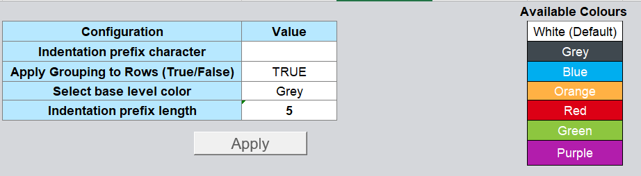
Configuration area | Indentation prefix character | - Specify the character which is used for indentation, e.g. “-” (dash), “ “ (4 spaces)  - Each drill-down level will be intended with this character(s)
Configuration area | Apply grouping to rows (True/ False) | - True applies automatic drill-down level grouping
Configuration area | Select base level colour | - Each drill-down level will be differentiated by different shade level of selected colour
Configuration area | Indentation prefix length | - Indicates number of characters used for indentation, e.g. for “-” (dash) equals 1, for “ “ (4 spaces) equals 4
Configuration area | Apply button | - Apply changes from the configuration above
Configuration area | 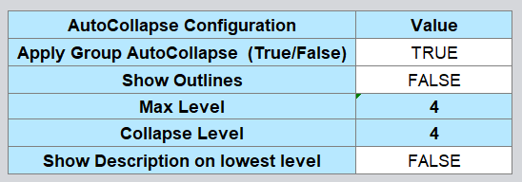
Configuration area | Apply Group AutoCollapse (True/ False) | - (default) Choose TRUE to enable automatic drilling in report  - FALSE will hide the AutoCollapse and disable automatic drilling in the report
Configuration area | Show Outlines | - (default) FALSE will hide outline symbols when grouping is used
Configuration area | Max Level | - Displays the number of drilled levels in the source data
Configuration area | Collapse Level | - Displays the drilled level shown when opening the report (it is chosen via Group AutoCollapse)
Configuration area | Show description on lowest level | - (default) Choose FALSE to display the description corresponding to the level  - TRUE will show the descriptions combined at the lowest level
Recommendations | - Use an already configured report in Discover

